Scary Game - Team 2

Team members: Andre S, Westin F, & Trinidy L

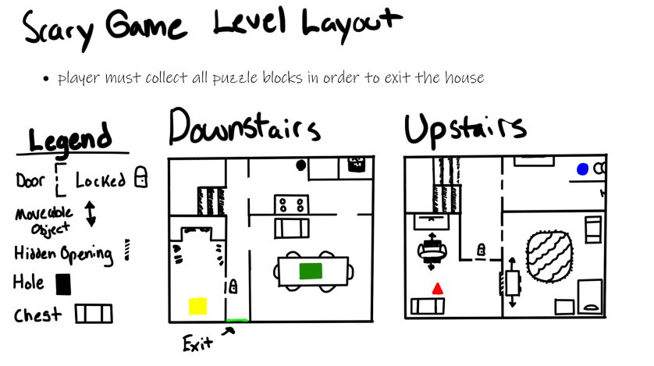

Level Design:

Our initial art direction is similar to Poppy Playtime, which is a child themed level design. We went with a house as our play area that includes the upstairs and downstairs levels. We’re currently debating if we should add a basement for a 3rd level (as of right now, we’re including a basement). The two levels would include 2 sets of shaped blocks for the player to bring back to the shape sorter. Each level will have hidden openings and moveable objects to interact with. The shape sorter will be located upstairs in the room with the rug.

Storyline:

The story revolves around a child attempting to escape a monster within their house. The child, assisted by a toy teddy bear, must locate all missing shapes from a shape sorter in order to open the exit door. However, the child is unaware that the toy teddy bear is part of the monster, luring the child to unlock the exit door where its real body lies, ready to be released and take over the child’s body.

Gameplay Mechanics / Puzzle Aspect:

The player would need to wander around the 2 levels (or 3) finding the shaped blocks and placing them into the shape sorter (you cannot proceed without finding all shapes). The player will have the ability to jump and push objects, although will not have the ability to sprint (only walking).

Gameplay:

A general idea of what to expect from our gameplay;

* First-person
* Interactivable environment
* Item collecting puzzle game
* SFX heavy gameplay

Technical Considerations:

* We would like to include the monster peeking around corners whenever the player finds a shape to add a fear factor into the gameplay.
* After the player collects all shapes and walks towards the exit, loud approaching footsteps will follow them.